76Table of Midi Note Conversions

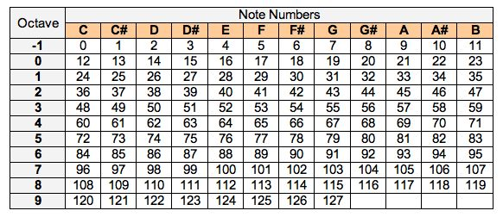

Scales

All scales derive their initial note from the -1st octave. Add 12 to each note in order to increase an octave. All notes are converted from frequency (Hz) to midi values.

|  |  |
| --- | --- |
| C Major Scale | |
| C | 0 |
| D | 2 |
| E | 4 |
| F | 5 |
| G | 7 |
| A | 9 |
| B | 11 |
| C | 12 |

|  |  |
| --- | --- |
| Bb Blues | |
| Bb | 10 |
| Db | 13 |
| Eb | 15 |
| E | 16 |
| F | 17 |
| Ab | 20 |
| Bb | 22 |

**Midi to Frequency (Hz) & Frequency (Hz) to Midi Conversion (Using tuning base 440)**

$$Midi=69+12\log_{2}{(\frac{Freq}{440 Hz})}$$

$$Freq=2^{\frac{Midi-69}{12}}×440 Hz$$

* **Note Variation** **🡪** utilization of an assortment of notes, sounds, and frequencies (vary pitch, velocity (attack), and duration)
* **Musical Randomization & Improvisation 🡪** generate music without premeditation or pre-composition (can apply to most other aspects)
* **Determinacy & Repetition 🡪** repeat notes, riffs, or strings of notes multiple times
* **Frequency Parameters 🡪** control over the parameters of the upper and lower extremes of pitch variation
* **Limit Step Size (Walks) 🡪** regulation of musical randomization & improvisation through limitations on jump ranges
* **Musical Scales 🡪** utilization of groups of notes that hold significance in music theory and frequency harmonics
* **Dynamics 🡪** change in the velocity, attack, and volume of notes
* **Duration 🡪** note lengths
* **Polyphony & Harmony 🡪** utilization of simultaneous and independent musical tendencies in complement to one another
* **Timbre 🡪** tone and quality of notes (instrumental variation)
* **Silence 🡪** periodic breaks in musical progression
* **Consonance & Dissonance 🡪** utilization of notes that do or do not blend well together
* **Imperfection** **🡪** swing, off-beat, and other aspects to make music *real*
* **Musical Structure 🡪** organization of music in bars, beats, and tempos
* **Progression** 🡪 feel of tempo, repeated choruses, beginning end, musical direction